**Testing Tips & Tricks**

Created By: Jamie Norem / Last Updated: March 15, 2018

**Wdesk**

1. **Wdesk Speed**
   1. Browser has to be **Chrome**
   2. Clear Cache at least once a week
      1. Click more options in the top right, , select more tools - clear browsing data, click Clear Browsing Data
      2. Caution: don’t clear cache while logged into Wdesk, it will kick you out
2. **IA Guides & Templates**
   1. Refer to Wdesk - Internal Audit Guides & Templates for IA guidance, before the network
      1. 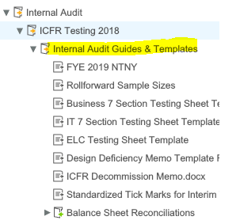
      2. If you need something archived or changed in Wdesk, please ask Megan Blackstone and Jo-Anne Lipa (IA Wdesk Administrators). For example, you need a new application added to the control universe or question added to the fraud questionnaire
      3. 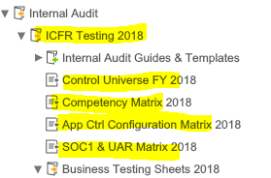
3. **Using Wdesk**
   1. When viewing Wdesk attachments, the file will display exactly as if the document was printed. As such, before attaching documents in Wdesk, use the “print preview” functions of the source applications (Excel, Adode/PDF, Word) to verify that the file margins and viewing orientation (portrait or landscape and paper size) is set-up as needed to enable complete viewing and readability in Wdesk. Check your print preview screens in excel & pdfs. Pdfs should be aligned correctly before attached to Wdesk (i.e., don’t attached with documents sideways)
   2. If you need to change the cell an attachment is tied to, select the attachment in Wdesk, in the right menu pane, the check mark will detach the document from the cell, select the cell you want and select the check mark again to attach the document to the new cell 
   3. If you need to download all the attachments in the section, in the right menu pane, select the attachments (paperclip), at the top of the menu pane, select the create download button. This will download all the attachments in that menu pane 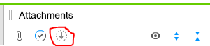
   4. Split Screen view – hold one tab, with your curser, drag down and to the right until you get the little green plus sign next to your curser, then release. Drag the tab and move to the left to get out of split screen
   5. Linking – please be mindful of the flow of Wdesk and our links
      1. Links start from the control universe to the “Business Consolidated Controls”(Top Section) – to the testing sheets – to the control summary sheets. Then, from the control summary sheets – to the status trackers
      2. Testers are responsible for correct linking
      3. Cut a blue link and paste it to another location, or copy a blue link and paste it to another location by selecting “make source link” on the clipboard (appears to the right of the pasted cell). The “make source link” option will make the blue link you copied from a green link.
   6. Add/edit name (preparer or reviewer) drop-down list
      1. Select the cell with the names drop-down, in the top left, go to Data, Validation, Edit Data Validation, double click in the window with all the names listed, select proceed, type your name, click Apply
      2. Should work for the entire document. If not, contact a of the Wdesk administrators
   7. Make sure text in all cells is viewable. Once the FY is locked, so is the view, and readability is difficult

**Workpapers**

1. **Test Plans & Testing**
   1. Population & Sampling
      1. Document population attributes and exclusions
      2. Explain sample size/calculation if ad-hoc
      3. Explain skipped samples
   2. Test Plans
      1. Types of test procedures – Direct Observation, Inspection, Re-performance, Inquiry, and Corroboration
      2. Distinguish between Inspection and Re-performance
      3. Specify exact items to be re-performed in the test step or include statement that selections re-performed will be described in the Test Table
   3. Test Tables
      1. Sample attributes (all column headers) should collectively be sufficient to uniquely identify a sample
      2. Specify exact items to be re-performed in the test step or include statement that selections re-performed will be described in the Test Table
      3. If all/many of the tick-marks are deviations (X1, X2, Y1, Y2), reconsider whether the Test Plan is designed right. Generally, we should only see extensive use of the X1, X2 series for management review controls (MRC’s) that need clear and thorough descriptions
   4. IUC
      1. For IUC’s/files comprised of multiple IUC’s, define each IUC
      2. Distinguish between IPE and IUC
   5. PII (Personally Identifiable Information)
      1. Ensure PII is scrubbed from document by either mgmt. (preference) or IA
2. **Tasking/Submitting Workpapers**
   1. Only submit when testing is complete - no incomplete items such as samples or questions pending supp docs from mgmt or assistance from the IA reviewer
   2. Status definitions are in Wdesk Guidance
   3. Task naming convention: Phase - Control # - Status (examples below)
      1. WT - AP 3 - Effective
      2. Lookback - AP 3 - Effective
      3. IUC - AP 3 – Effective
3. **Formatting & “Angelisms”**
   * 1. Use standard text format and size - **Ariel size 10** & **align cells top left**
     2. Dates should be the full range - January 1, 2018
     3. DO NOT USE “note” or “noted”
     4. Use full names & titles of employees
     5. Test steps should be past tensetyl
     6. Write for audience understanding – clarity, accuracy, building credibility and relationships, dialogue is appropriate for audience
     7. Grammar and readability – organize the message (outlines, paragraphs, bullets, tables), succinct sentences, correct grammar, avoid Active vs. passive voice